1. Dual in-line package (DIP) is an electronic component package with a rectangular housing and two parallel rows of electrical connecting pins.[1] LM386 we use in Lab 1 is an integrated circuit (IC) consists of an 8 pin dual in-line package (DIP).

Small outline package (SOP) is a type of surface mount IC package. SOIC and MSOP are typical type of SOP, where SOIC stands for small outline integrated circuit, and MSOP stands for micro small outline package.

SOP reduce the area between pins significantly from DIP, and pins have ‘gull wing’ shape in order to increase the surface.[2] For example, Thin SOP occupies an area about 30~50% less than an equivalent DIP, with typical thickness that is 70% less.[3]

1. Observation on given datasheet of LM386, we are able to find that

the typical bandwidth (BW) in the condition: [Vs = 6V, Pins 1 and 8 open] is **300 kHz**

LM386 has wide operating supply voltage (Vs) range:

* **4V to 12V** for LM386N-1, -3, LM386M-1, LM386MM-1
* **5V to 18V** for LM386N-4.

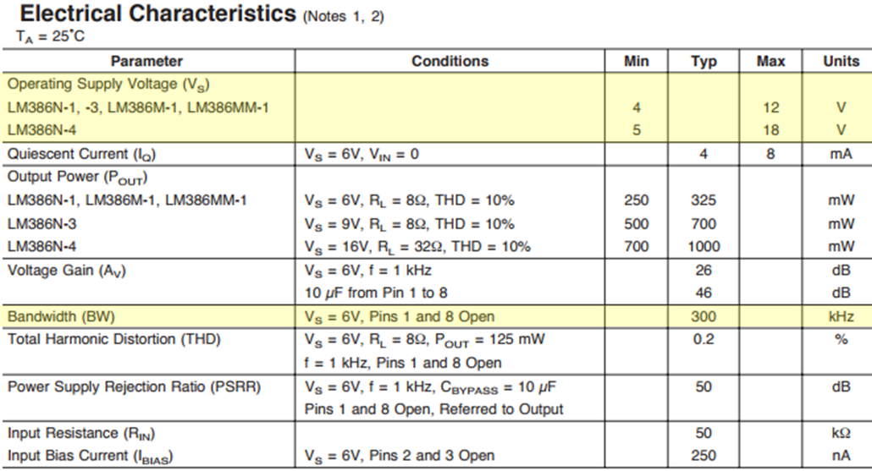

1. 1) Set the gain at 50

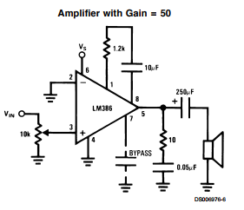

Place a 1.2k $Ω$ resistor a capacitor from pin 1 to 8, in order to set the gain at 50.

2) Set the gain at 200

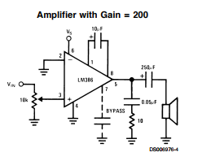

Place a capacitor from pin 1 to 8, in order to set the gain at 200.

1. With my understanding, I cannot calculate the gain from below schematic. But in problem 3, we learned that adding a capacitor with resistors can make current bypass the 1.35 k $Ω$ resistor, resulting increased gain. So we can assume that if pin 1 and 8 are open, all the current flows through 1.35k $Ω$ resistor, and set the gain to minimum value available from the circuit: 20.

1. <https://en.wikipedia.org/wiki/Dual_in-line_package>
2. <http://www.chip1stop.com/web/KOR/ko/tutorialContents.do?page=045>
3. <https://en.wikipedia.org/wiki/Thin_Small_Outline_Package>